

COMPILER DESIGN
(22CS2235F)

STUDENT ID:2420030046 ACADEMIC YEAR: 2025-26 STUDENT NAME: Nimma Lasya
Table of Contents
- Session 01: Removing white spaces and comments Using LEX Tool 1
- Session 02: Lexer Tokenization Process focusing on keywords using LEX tool 10
- Session 03: Automating Lexical Analyzer Generation Using LEX Tool 21
- Session 04: Elimination of Left Recursion from given CFG 30
- Session 05: Implement Program to compute the FIRST set from the CFG 40
- Session 06: Implement Program to compute the FOLLOW set from the CFG 49
- Session 07: Implement Program for Constructing LL(1) Parsing table 59
- Session 08: Implement Program for Shift-Reduce parser 64
- Session 09: Implementation of LR parser 69
- Session 10: Implement a System to generate and interpret quadruples 73
- Session 11: Implement code optimization technique 78
- Session 12: Implement a module for generating intermediate code 83
- Session 13: Implement basic error detection and reporting system 88
A.Y. 2024-2025 LAB/SKILL CONTINUOUS EVALUATION
S.No | Date | Experiment Name | Pre- Lab (10M) | In-Lab (25M) |  |  | Post-Lab (10M) | Viva Voce (5M) | Total (50M) | Faculty Signature
 |  |  |  | Program/ Procedure (5M) | Data and Results (10M) | Analysis and Inference  (10M)
1. |  | Removing white spaces and comments Using LEX Tool
2. |  | Lexer Tokenization Process focusing on keywords using LEX tool
3. |  | Automating Lexical Analyzer Generation Using LEX Tool
4. |  | Elimination of Left Recursion from given CFG
5. |  | Program to compute FIRST set for given CFG
6. |  | Program to compute FOLLOW set for given CFG
7. |  | Construction Of LL(1) Parsing table
8. |  | Build Shift-Reduce parser
9. |  | Implement of LR parser
10. |  | Implement a System to generate and interpret quadruples
11. |  | Implement code optimization technique
12. |  | Implement a module for generating intermediate code
13. |  | Implement basic error detection and reporting system

Session 1:
Experiment Title: Removing white spaces and comments Using LEX Tool.
Aim/Objective:
The aim of this lab session is to introduce students to programming for some small program in a HLL, such as C, that enables them to understand the working of small subset of the Lexical analyser. This familiarity will enable them to build confidence, and understanding of the overall module of the lexical analysis (scanning).
Description:
In this lab session, students will learn about
- To understand how to eliminate white space and comments Pre-Requisites:
Students should have a basic understanding of the C language, and the ability to program using different constructs of the same.
Comment of the Evaluator (if Any) | Evaluator’s Observation Marks Secured out of 50  Signature of the Evaluator
#source Code
%%writefile whitespace.c
#include <stdio.h>

int main()
{
char str[100];
int i;

printf("Enter any statement: ");
fgets(str, sizeof(str), stdin);

printf("Statement without spaces: ");

for(i = 0; str[i] != '\0'; i++)
{
if(str[i] != ' ')
{
printf("%c", str[i]);
}
}
–––
return 0;
}

Runing step:
!gcc whitespace.c -o whitespace
!./whitespace

Output:


Session 2:
Experiment Title: Lexer Tokenization Process focusing on keywords using LEX tool.
Aim/Objective:
The aim of this lab session is to introduce students to programming a scanner for some small program (set of input strings) in a HLL, as C. This familiarity will enable them to kick start into the topic, while comparing their program with an actual one, such as LEX. That would make them aware of their shortcomings in terms of the breadth and depth of the subject of lexical analyser, for a real programming language C.
It is hoped that this will make them improve upon their version, by goading them to follow the industry standards.
Learning Outcomes:
- To understand how to design a lexical analyzer for a given language
Source Code
KEYWORDS = {
"int", "float", "char", "double", "void",
"if", "else", "while", "for", "do", "switch", "case", "default",
"break", "continue", "return", "goto",
"struct", "union", "enum", "typedef",
"const", "volatile", "static", "extern", "auto", "register"
}
def tokenize(code):
tokens = []

# Split by whitespace and punctuation

import re
words = re.findall(r"[A-Za-z_][A-Za-z0-9_]*|\d+|[^\s]", code)

for word in words:
if word in KEYWORDS:
tokens.append(("KEYWORD", word))
elif re.match(r"[A-Za-z_][A-Za-z0-9_]*", word):
tokens.append(("IDENTIFIER", word))
elif re.match(r"\d+", word):
tokens.append(("NUMBER", word))
else:
tokens.append(("SYMBOL", word))
return tokens
# Example usage
code = "int x = 5; if (x > 0) return x;"
tokens = tokenize(code)
for token in tokens:
print(token)

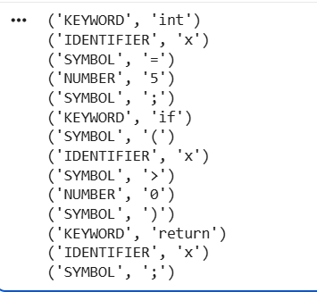

Comment of the Evaluator (if Any) | Evaluator’s Observation Marks Secured out of 50  Signature of the Evaluator

(For Evaluator’s use only)

Session 3:
Experiment Title: Automating Lexical Analyzer Generation Using LEX Tool. Aim/Objective:
The aim of this lab session is to make the students conversant with the details of the LEX tool, which is an off-the-shelf tool for building scanners.
Description:
In this lab session, students will learn how to use LEX to build for a given smallish subset of C, or any other language, using the given off-the-shelf tool.
Pre-Requisites:
Students should have a basic understanding of lexical analysis process, C language.
#program 3:
%%writefile program.l
%{
#include <stdio.h>
%}
%%
"int"|"float"|"char"|"double"|"void"|"if"|"else"|"while"|"for"|"return"|"break"|"continue"|"switch"|"case" {
printf("'%s' is a Keyword\n", yytext);
}
[a-zA-Z_][a-zA-Z0-9_]* {
printf("'%s' is an Identifier\n", yytext);
}

[0-9]+ {
printf("'%s' is a Number\n", yytext);
}

[ \t\n] {
/* Ignore whitespace, tabs, and newlines */
}
. {
printf("'%s' is an Unknown Character/Operator\n", yytext);
}
%%
int main() {
printf("Enter code snippet to analyze (Press Ctrl+D to stop):\n");
yylex();
return 0;
}

int yywrap() {
return 1;
}

Installation steps:
%%shell
sudo apt-get update && sudo apt-get install -y flex
running command:
%%shell
lex -l program.l
gcc lex.yy.c
./a.out
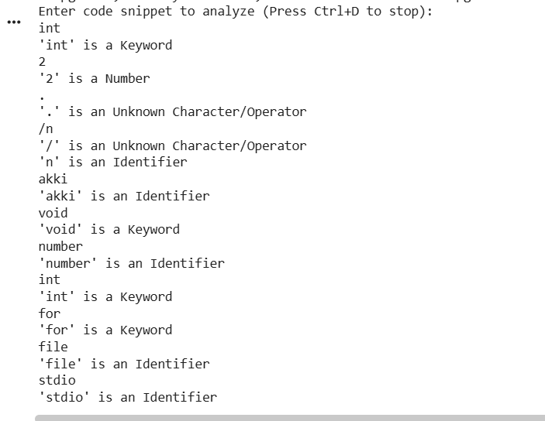

Comment of the Evaluator (if Any) | Evaluator’s Observation Marks Secured out of 50  Signature of the Evaluator

(For Evaluator’s use only)

Program No:4
WRITE A C PROGRAM TO IMPLEMENT RECURSIVE DECENT PARSER FOR GRAMMAR:-
Aim
To write a C program to implement a Recursive Descent Parser and check whether the given input string is accepted by the grammar.
Description
A Recursive Descent Parser is a simple top-down parsing method. It uses different functions for different grammar rules. The program reads the input and checks whether it follows the given grammar. If it follows the grammar, the string is accepted; otherwise, it is rejected.
Pre-requisites
- Basic knowledge of C programming
- Basic knowledge of Compiler Design
- Understanding of grammar and production rules
- Knowledge of terminals and non-terminals
- Basic understanding of recursion
- Basic idea of parsing
%%writefile program1.c
#include<stdio.h>
#include<string.h>
#include<ctype.h>
int i,err;
char inp[10];
void E();
void E1();
void T();
void T1();
void F();
void main(){
i=0,err=0;
printf("Enter String: ");
scanf("%s",inp);
E();
if(strlen(inp)==i && err==0)
printf("\t\t*****STRING ACCEPTED!!!!!!!!!*****\n\n");
else
printf("\t\t*****STRING NOT ACCEPTED!!!!*****\n\n");
}
void E(){
T();
E1();
}
void E1(){
if(inp[i]=='+'){
i++;
T();
E1();
}
}

void T(){
F();
T1();
}
void T1(){
if(inp[i]=='*'){
i++;
F();
T1();
}
}
void F(){
if(isalnum(inp[i]))
i++;
else if(inp[i]=='('){
i++;
E();
if(inp[i]==')')
i++;
else
err=1;
}
else
err=1;
}
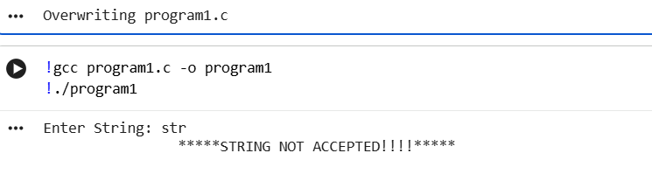

Session 4.1:
Experiment Title: Elimination of Left Recursion from given CFG (Context Free Grammar)

Aim/Objective:
The aim of this lab session is to introduce students to solution of the left recursive grammars, and the issue of infinite loop, associated with its top-down parser.

Description:
In this lab session, students will learn about CFG, and remove the problem of left recursion.

Pre-Requisites:
Students should have a basic understanding of top-down parsing, and how it is performed.

#program 5:: Elimination of Left Recursion from given CFG
%%writefile kkr.c
#include <stdio.h>
#include <string.h>
#include <stdlib.h> // For EXIT_FAILURE

int main() {
char rule[100];

// 1. Accept standard production rule format
printf("Enter production rule (e.g., A->Aa|b): ");
if (scanf("%99s", rule) != 1) return EXIT_FAILURE; // Use EXIT_FAILURE

char lhs = rule[0]; // Left-hand side non-terminal character

// 2. Identify direct left recursion layout (e.g., A -> A...)
if (rule[1] == '-' && rule[2] == '>' && rule[3] == lhs) {
char *pipe_ptr = strchr(rule, '|'); // Correct: use char *

if (pipe_ptr != NULL) {
printf("\nOriginal Rule: %s\n", rule);
printf("\nRules After Eliminating Left Recursion:\n");

// 3. Print the first new rule: A -> beta A'
printf("%c -> ", lhs);
// Print characters from after '|' until the end of the string
for (char *p = pipe_ptr + 1; *p != '\0'; p++) {
putchar(*p);
}
printf("%c'\n", lhs);

// 4. Extract and print the alpha rule: A' -> alpha A' | e
printf("%c' -> ", lhs);
// Print characters from &rule[4] (start of alpha) up to '|'
for (char *ptr_alpha = &rule[4]; ptr_alpha < pipe_ptr; ptr_alpha++) { // Correct: use char *
putchar(*ptr_alpha);
}
printf("%c' | e\n", lhs);
} else {
printf("\nFormat Error: Missing option separator pipeline ('|').\n");
}
} else {
printf("\nNo direct left recursion detected in this rule.\n");
}
return 0;
}

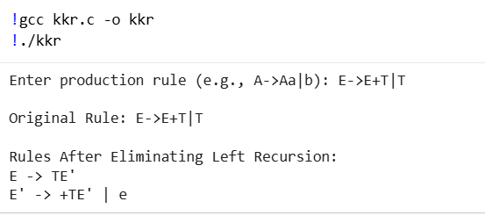

Comment of the Evaluator (if Any) | Evaluator’s Observation Marks Secured out of 50  Signature of the Evaluator

Session 5:
Experiment Title: Implement Program to compute the FIRST set from the CFG.

Aim/Objective:
To make the student conversant with the predictive parser (top-down) need to know the FIRST set, in order to parse without backtracking.
Description:
The experiment involves the following steps:
  - Understand the working of a top-down parser.
  - How is there the need to backtrack in the normal top-down search.
  - Understand why the given parsing, needs for correct prediction the FIRST set.
  - How to compute the FIRST set for the different grammar symbols.
Pre-Requisites:
Students should have a basic understanding of top-down search process, and the left-to-right derivation that can be derived from that in parsing, with left side symbol of a production replaced by the rhs string.

#program 5:: Elimination of Left Recursion from given CFG
%%writefile kkr.c
#include <stdio.h>
#include <string.h>
#include <stdlib.h> // For EXIT_FAILURE

int main() {
char rule[100];

// 1. Accept standard production rule format
printf("Enter production rule (e.g., A->Aa|b): ");
if (scanf("%99s", rule) != 1) return EXIT_FAILURE; // Use EXIT_FAILURE

char lhs = rule[0]; // Left-hand side non-terminal character

// 2. Identify direct left recursion layout (e.g., A -> A...)
if (rule[1] == '-' && rule[2] == '>' && rule[3] == lhs) {
char *pipe_ptr = strchr(rule, '|'); // Correct: use char *

if (pipe_ptr != NULL) {
printf("\nOriginal Rule: %s\n", rule);
printf("\nRules After Eliminating Left Recursion:\n");

// 3. Print the first new rule: A -> beta A'
printf("%c -> ", lhs);
// Print characters from after '|' until the end of the string
for (char *p = pipe_ptr + 1; *p != '\0'; p++) {
putchar(*p);
}
printf("%c'\n", lhs);

// 4. Extract and print the alpha rule: A' -> alpha A' | e
printf("%c' -> ", lhs);
// Print characters from &rule[4] (start of alpha) up to '|'
for (char *ptr_alpha = &rule[4]; ptr_alpha < pipe_ptr; ptr_alpha++) { // Correct: use char *
putchar(*ptr_alpha);
}
printf("%c' | e\n", lhs);
} else {
printf("\nFormat Error: Missing option separator pipeline ('|').\n");
}
} else {
printf("\nNo direct left recursion detected in this rule.\n");
}
return 0;
}

Output:
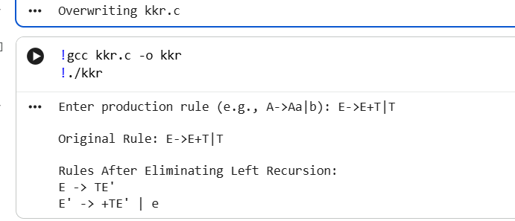

(For Evaluator’s use only)

Comment of the Evaluator (if Any) | Evaluator’s Observation Marks Secured out of 50  Signature of the Evaluator

Session 6 :
Experiment Title: Implement a program to compute FOLLOW Set. Aim/Objective:
To make the student conversant with the predictive parser (top-down) need to know the FOLLOW set, in order to parse without backtracking.
Description:
The experiment involves the following steps:
  - Understand the situations where there is need to compute the FOLLOW set, for a top-down parser. Why top-down search might need to backtrack, in absence of the FOLLOW set.
  - How to compute the FOLLOW set.

Pre-Requisites:
Students should have a basic understanding of top-down search process, and the left-to-right derivation that can be derived from that in parsing, with left side symbol of a production replaced by the RHS string.
%%writefile follow.c
#include <stdio.h>
#include <string.h>
char production[20][20];
int n;
int isNonTerminal(char ch) {
return ch >= 'A' && ch <= 'Z';
}
void findFollow(char symbol) {
int i, j;
if (symbol == production[0][0]) {
printf("$ ");
}
for (i = 0; i < n; i++) {
for (j = 3; production[i][j] != '\0'; j++) {
if (production[i][j] == symbol) {
if (production[i][j + 1] != '\0') {
char next = production[i][j + 1];
if (!isNonTerminal(next)) {
if (next != 'e')
printf("%c ", next);
}
}
else {
if (production[i][0] != symbol)
findFollow(production[i][0]);
}
}
}
}
}

int main() {
char symbol;

printf("Enter number of productions: ");
scanf("%d", &n);

printf("Enter productions (e.g., S->AB):\n");

for (int i = 0; i < n; i++) {
scanf("%s", production[i]);
}

printf("\nEnter non-terminal to find FOLLOW: ");
scanf(" %c", &symbol);

printf("\nFOLLOW(%c) = { ", symbol);

findFollow(symbol);

printf("}\n");

return 0;
}

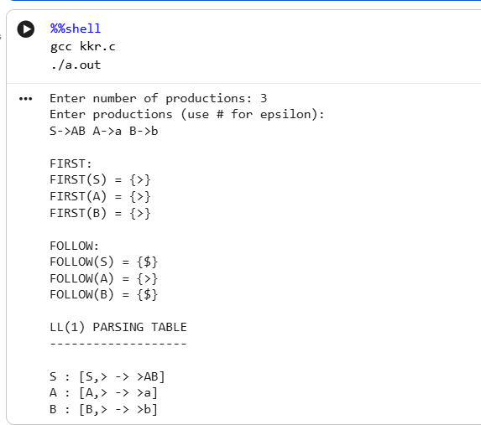

(For Evaluator’s use only)

Comment of the Evaluator (if Any) | Evaluator’s Observation Marks Secured out of 50  Signature of the Evaluator

Session 7:
Experiment Title: Implement program for constructing LL(1) parsing.
%%writefile kkr.c
#include <stdio.h>
#include <string.h>
#include <ctype.h>

#define MAX 20

char prod[MAX][20];
char first[26][20], follow[26][20];
int n;

void add(char *s, char c)
{
if (!strchr(s, c)) {
int l = strlen(s);
s[l] = c;
s[l + 1] = '\0';
}
}

int isNT(char c)
{
return (c >= 'A' && c <= 'Z');
}

void FIRST(char nt)
{
int i, j;
for (i = 0; i < n; i++) {
if (prod[i][0] != nt)
continue;

char *rhs = prod[i] + 2;

if (rhs[0] == '#') {
add(first[nt - 'A'], '#');
}
else if (!isNT(rhs[0])) {
add(first[nt - 'A'], rhs[0]);
}
else {
char x = rhs[0];

if (first[x - 'A'][0] == '\0')
FIRST(x);

for (j = 0; first[x - 'A'][j]; j++)
add(first[nt - 'A'], first[x - 'A'][j]);
}
}
}
void FOLLOW()
{
int i, j, k;

add(follow[prod[0][0] - 'A'], '$');

for (k = 0; k < n; k++) {
for (i = 0; i < n; i++) {
char A = prod[i][0];
char *rhs = prod[i] + 2;

for (j = 0; rhs[j]; j++) {
if (isNT(rhs[j])) {
char B = rhs[j];

if (rhs[j + 1] != '\0') {
char x = rhs[j + 1];

if (!isNT(x))
add(follow[B - 'A'], x);
else {
for (int m = 0; first[x - 'A'][m]; m++)
if (first[x - 'A'][m] != '#')
add(follow[B - 'A'],
first[x - 'A'][m]);
}
}
else {
for (int m = 0; follow[A - 'A'][m]; m++)
add(follow[B - 'A'],
follow[A - 'A'][m]);
}
}
}
}
}
}
int main()
{
int i, j;
printf("Enter number of productions: ");
scanf("%d", &n);
printf("Enter productions (use # for epsilon):\n");
for (i = 0; i < n; i++)
scanf("%s", prod[i]);
/* FIRST */
for (i = 0; i < n; i++)
FIRST(prod[i][0]);
/* FOLLOW */
FOLLOW();
printf("\nFIRST:\n");
for (i = 0; i < n; i++) {
char A = prod[i][0];
if (i == 0 || prod[i - 1][0] != A)
printf("FIRST(%c) = {%s}\n",
A, first[A - 'A']);
}

/* LL(1) Parsing Table */
printf("\nLL(1) PARSING TABLE\n");
printf("-------------------\n");

for (i = 0; i < n; i++) {
char A = prod[i][0];

if (i > 0 && prod[i - 1][0] == A)
continue;

printf("\n%c : ", A);

for (j = 0; j < n; j++) {
if (prod[j][0] != A)
continue;

char *rhs = prod[j] + 2;

if (rhs[0] == '#') {
for (int k = 0; follow[A - 'A'][k]; k++)
printf("[%c,# -> #] ",
follow[A - 'A'][k]);
}
else if (!isNT(rhs[0])) {
printf("[%c,%c -> %s] ",
A, rhs[0], rhs);
}
else {
char B = rhs[0];

for (int k = 0; first[B - 'A'][k]; k++)
if (first[B - 'A'][k] != '#')
printf("[%c,%c -> %s] ",
A, first[B - 'A'][k], rhs);
}
}
}

printf("\n");
return 0;
}

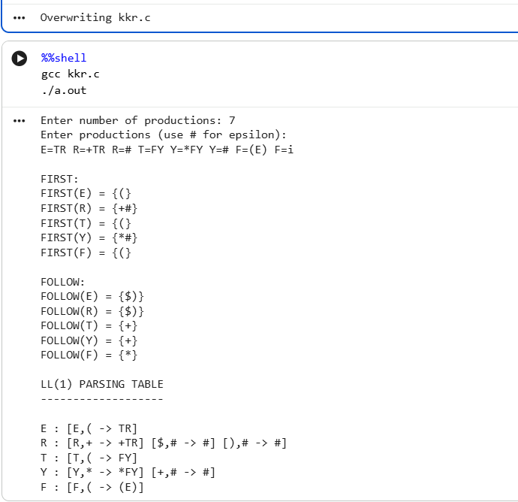

(For Evaluator’s use only)

Comment of the Evaluator (if Any) | Evaluator’s Observation Marks Secured out of 50  Signature of the Evaluator

Session 8:

Experiment Title: Implement a program for shift-reduce parser.
%%writefile shift_reduce.c
#include <stdio.h>
#include <string.h>
int main()
{
char stack[50], input[50];
int top = -1, i = 0;
printf("Enter input string: ");
scanf("%s", input);
printf("\nSTACK\tINPUT\tACTION\n");
while (input[i] != '\0') {
stack[++top] = input[i++];
stack[top + 1] = '\0';
printf("%s\t%s\tSHIFT\n", stack, input + i);
if (top >= 1 &&
stack[top - 1] == 'i' &&
stack[top] == 'd') {
top -= 1;
stack[top] = 'E';
stack[top + 1] = '\0';
printf("%s\t%s\tREDUCE E->id\n",
stack, input + i);
}
if (top >= 2 &&
stack[top - 2] == 'E' &&
stack[top - 1] == '+' &&
stack[top] == 'E') {
top -= 2;
stack[top] = 'E';
stack[top + 1] = '\0';
printf("%s\t%s\tREDUCE E->E+E\n",
stack, input + i);
}
}
if (strcmp(stack, "E") == 0)
printf("\nString Accepted!\n");
else
printf("\nString Rejected!\n");
return 0;
}

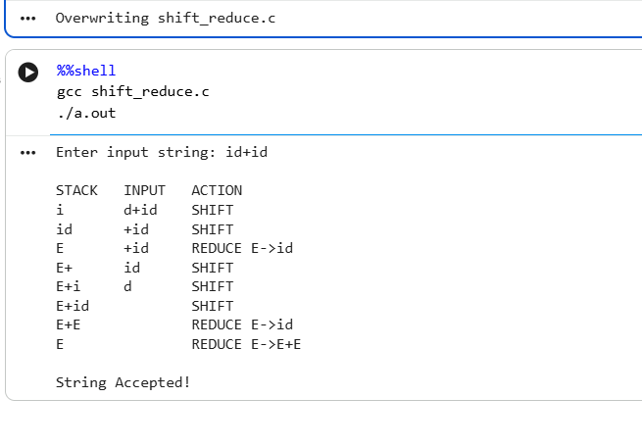

(For Evaluator’s use only)

Comment of the Evaluator (if Any) | Evaluator’s Observation Marks Secured out of 50  Signature of the Evaluator

Session 9:
Experiment Title: Implement Program for LR parser.
%%writefile lr_parser.c
#include <stdio.h>
#include <string.h>
char stack[100];
int top = -1;
void push(char c)
{
stack[++top] = c;
stack[top + 1] = '\0';
}
void pop(int n)
{
top -= n;
stack[top + 1] = '\0';
}
int main()
{
char input[100];
int i = 0;
printf("Enter input string: ");
scanf("%s", input);
printf("\nSTACK\tINPUT\tACTION\n");
while (input[i] != '\0') {
/* Shift */
if (input[i] == 'i' && input[i + 1] == 'd') {
push('i');
push('d');
i += 2;
printf("%s\t%s\tSHIFT id\n",
stack, input + i);
/* Reduce F -> id */
pop(2);
push('F');
printf("%s\t%s\tREDUCE F->id\n",
stack, input + i);
/* Reduce T -> F */
pop(1);
push('T');
printf("%s\t%s\tREDUCE T->F\n",
stack, input + i);
/* Reduce E -> T */
if (input[i] == '\0' || input[i] == '+') {
pop(1);
push('E');
printf("%s\t%s\tREDUCE E->T\n",
stack, input + i);
}
}

else if (input[i] == '+') {
push('+');
i++;
printf("%s\t%s\tSHIFT +\n",
stack, input + i);
}
else {
printf("\nString Rejected!\n");
return 0;
}
}
if (strcmp(stack, "E") == 0)
printf("\nString Accepted!\n");
else
printf("\nString Rejected!\n");
return 0;
}
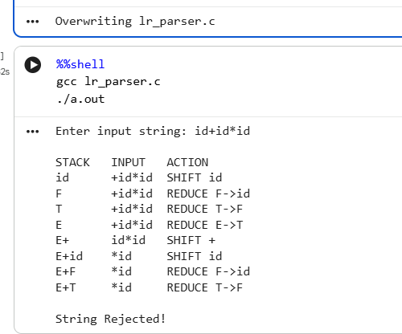

Comment of the Evaluator (if Any) | Evaluator’s Observation Marks Secured out of 50  Signature of the Evaluator

(For Evaluator’s use only)
Session 10:
Experiment Title: Implement a System to generate and interpret quadruples.
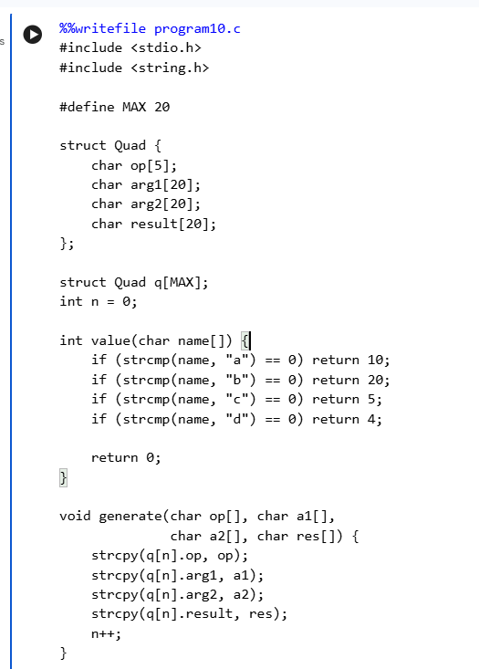
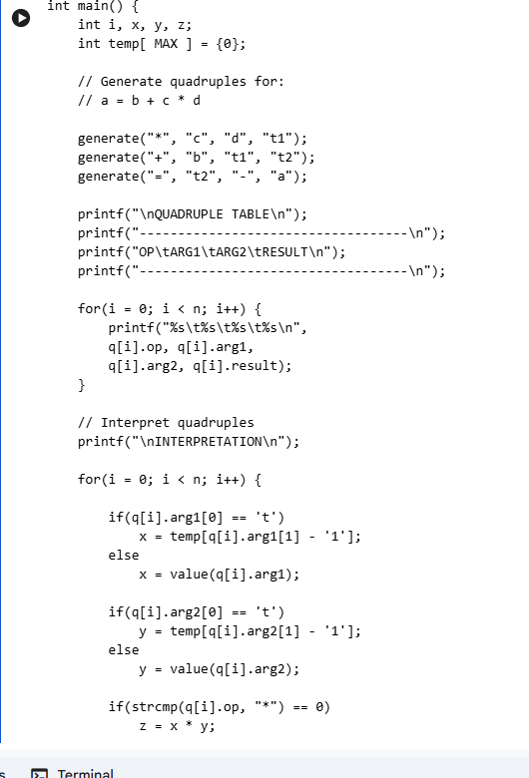

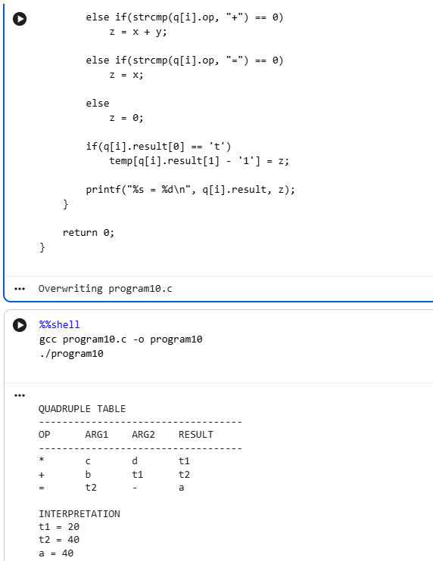

(For Evaluator’s use only)
Comment of the Evaluator (if Any) | Evaluator’s Observation Marks Secured out of 50  Signature of the Evaluator

Session 11:
Experiment Title: Implement a simple code optimization technique.

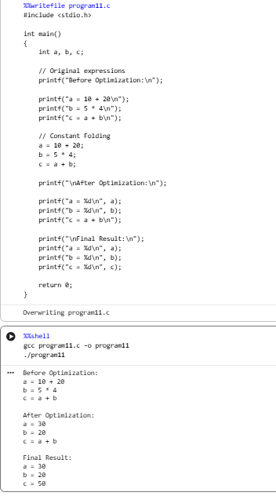

(For Evaluator’s use o
Comment of the Evaluator (if Any) | Evaluator’s Observation Marks Secured out of 50  Signature of the Evaluator

Session 12:
Experiment Title: Implement a module for generating intermediate code.
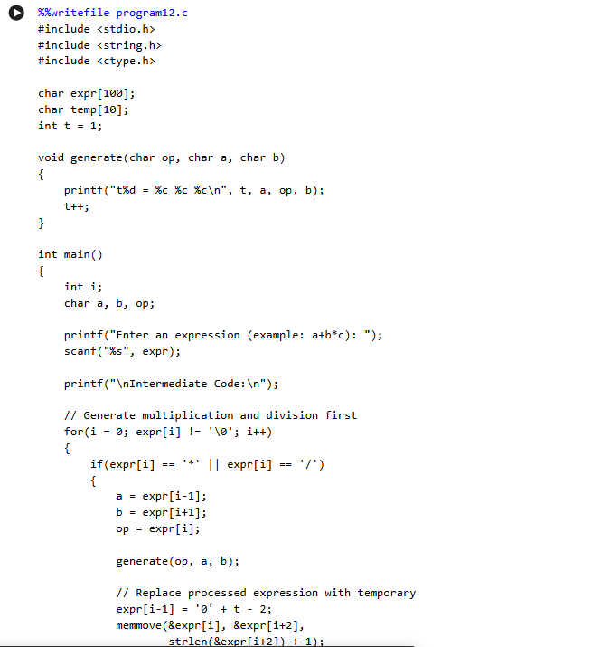

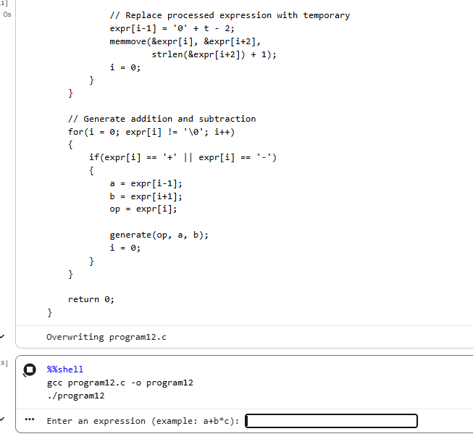

(For Evaluator’s use only)

Comment of the Evaluator (if Any) | Evaluator’s Observation Marks Secured out of 50  Signature of the Evaluator

Session 13:
Experiment Title: Implement basic error detection and reporting system.
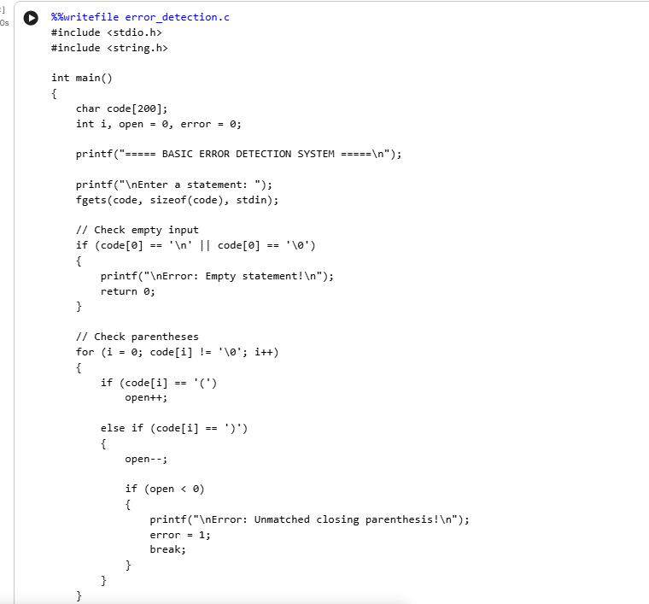

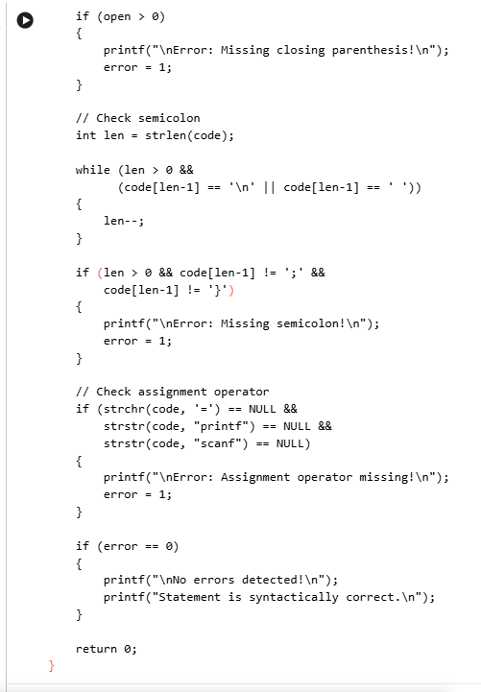

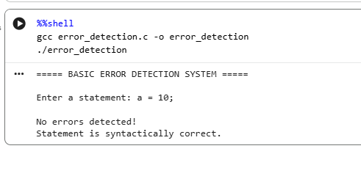

(For Evaluator’s use only)

Comment of the Evaluator (if Any) | Evaluator’s Observation Marks Secured out of 50  Signature of the Evaluator

